**Project Title**

**A Web-Based Hospital Appointment & Emergency Scheduling System**

**Submitted By**

**Md. Anamul Haque**

Roll: MUH2011035M

Session: 2019-20

Project Supervisor

**Tanvir Zaman Khan**

Assistant Professor

Department of Information and Communication Engineering



NOAKHALI SCIENCE AND TECHNOLOGY UNIVERSITY

INFORMATION & COMMUNICATION ENGINEERING

Noakhali-3814, Bangladesh

**Date: 16th July, 2025**

**DECLARATION**

This project report is submitted to the Department of Information and Communication Engineering (ICE), Noakhali Science and Technology University, Noakhali-3814, in partial fulfilment of the requirement for having the B.Sc. degree in ICE under the course entitled with “ICE-4218”. So, I, here by declare that this project report has not been submitted elsewhere for the requirement of any kind of degree, diploma or publication.

**Md. Anamul Haque**

Roll No: MUH2011035M

Session: 2019-20

Year: 4, Term: II

Department of Information and Communication Engineering

Noakhali Science and Technology University,

Noakhali-3814.

**Acceptance**

This project report is submitted to the Department of Information and Communication Engineering (ICE), Noakhali Science and Technology University, Noakhali-3814, in partial fulfilment of the requirements for having the B.Sc. degree in ICE under the course entitles “ICE-4218”.

**Tanvir Zaman Khan**

Assistant Professor

Department of Information and Communication Engineering

Noakhali Science and Technology University,

Nokhali-3814

**Abstract**

This project presents Prescripto, a scalable and role-based hospital appointment and emergency management system developed using the MERN stack (MongoDB, Express.js, React, Node.js). The system provides dedicated, user-friendly web interfaces for patients, doctors, and administrators to streamline hospital appointment workflows and emergency handling. Patients can register, book appointments based on doctor availability, view their booking history, and request emergency consultations that receive priority scheduling. Doctors manage their schedules, update profiles, and track appointment statuses through an intuitive dashboard. Administrators oversee user management, doctor onboarding, appointment monitoring, and real-time hospital activity reporting via a centralized admin panel. Prescripto incorporates secure authentication, role-based access control, and RESTful APIs to ensure data integrity and system security. The emergency override feature intelligently reschedules non-urgent appointments to prioritize critical cases, enhancing responsiveness and operational efficiency. Designed for scalability and maintainability, Prescripto improves hospital workflow efficiency, reduces manual errors, and enhances the patient care experience.

**Table of Contents**

**Page No.**

**Abstract i**v

**List of Figures** vii

**Chapter 1 INTRODUCTION 1**

1.1 Introduction 1

1.2 Background Study1

1.3 Problem Statement 2

1.4 Motivation 3

1.5 Objectives3

**Chapter 2 LITERATURE REVIEW 4**

2.1 Introduction 4

2.2 Manual System 4

2.3 Related Work 5

**Chapter 3 METHODOLOGY 15**

3.1 Requirement Engineering 15

3.2 Proposed Process Model16

3.3 Technology and Tools17

3.4 Use Case Diagram 21

3.5 E-R Diagram 22

3.6 Testing 23

3.7 Maintenance 23

**Chapter 4 RESULT 24**

4.1 Home Page 24

4.2 About Us Page26

4.3 Contact Us Page27

4.4 All Doctors Page 28

4.5 Search by Specialty 29

4.6 Make an Appointment 31

4.7 Emergency Appointment 32

4. 8 Pay Online 33

4.9 Cancel an Appointment 35

4.10 User Login, register and Profile 36

4. 11 Admin Login and Doctors Login 38

4. 12 Admin Panel 39

4. 13 Doctor Panel 41

**Chapter 5 CONCLUSION 43**

5.1 Conclusion 43

5.2 Future Work 43

**References 44**

**LIST OF FIGURES**

**Figure Title Page No.**

Figure 2.1 Appointment Page of BIRDEM General Hospital. 6

Figure 2.2 Appointment booking of Square Hospital website 7

Figure 2.3 Make an Appointment Evercare Hospital Dhaka 8

Figure 2.4 Dhaka Medical College Hospital 9

Figure 2.5 Bangladesh Specialized Hospital 10

Figure 2.6 Appointment Page of Apollo Imperial Hospitals 11

Figure 2.7 Appointment Page of Prime Hospital Ltd. 12

Figure 2.8 Mayo Clinic in Rochester, Minnesota. 13

Figure 3.1 Agile Software Development Model. 16

Figure 3.2 Use Case Diagram of Appointment Booking System 21

Figure 3.3 ER diagram of appointment management System 22

Figure 4.1 Home Page 25

Figure 4.2 About Us Page 26

Figure 4.3 Contact Us Page 27

Figure 4.4 All Doctors Page 29

Figure 4.5 Search by Specialty 31

Figure 4.6 Make an Appointment: 31

Figure 4.7 Emergency Appointment 32

Figure 4.8 Pay Online 34

Figure 4.9 Cancel an Appointment 35

Figure 4.10 User Login, register and Profile 37

Figure 4. 11 Admin Login and Doctors Login 38

Figure 4. 12 Admin Panel 40

Figure 4. 13 Doctor Panel 42

**List of Table**

**Table Title Page No.**

Table 2.1 A summary of related project on Appointment Booking in HMS. 14

**Chapter 1**

**INTRODUCTION**

**1.1 Introduction**

Healthcare is a critical sector where timely and efficient management of patient appointments and emergency cases directly impacts the quality of care and patient outcomes. With increasing patient loads and the complexity of hospital operations, traditional manual appointment scheduling often leads to errors, delays, and poor resource utilization. To address these challenges, digital solutions that streamline appointment management and provide real-time emergency handling have become essential. This project provides, Hospital Appointment and Emergency Management application on the web. System. This is concerned to do with making the most out of the appointment booking process by giving patients, has dedicated dashboard by doctors, administrators. The patients are able to make reservations depending on the availability of doctors, they place emergency consultations that are automatically made a priority by means of a smart override system. The physicians will be able to organize their time well, and revise availability, keep track of appointment statuses and administrators gained complete control over the hospital processes such as taking care of doctors, managing patients, tracking appointments and real time reporting. By computerizing these essential processes, fewer mistakes are made, and scheduling is minimised conflicts, and enhances response to emergency healthcare.

**1.2 Background Study**

The healthcare institutions including hospitals have many challenges in the maintenance and running of the operations in the institutions, particularly regarding handling the appointment and emergency cases properly. Manual customer appointment scheduling, patient registration and interdepartmental communication processes are time-wasting, rife with error, and may cause conflicts in the schedule or hindrances when a higher priority customer is needed to be helped as soon as possible. Digital solutions have also improved the management of healthcare services due to technology upgrading, as work processes are automated, and patients, doctors, and administrators may exchange data without any barriers. Although there are numerous hospital management systems (HMS) out there, they are usually not flexible or to the needs of appointment scheduling and manage emergency in all sizes of hospitals. Customisable and tailored appointment and emergency management system is necessary in order to facilitate patient bookings and focus on emergency cases, as well as better resource allocation.

The project aims to overcome these challenges by the creation of scalable, secure, and user-friendly Hospital Appointment and Emergency Management System that will allow efficient scheduling, positive reactions to emergencies, and sustain requirements of the healthcare provider in the changing environment.

**1.3 Problem Statement**

Most hospitals fail to adopt newer or more efficient appointment scheduling strategies as much of its previously implemented technologies are still manual-based or unsynchronized with each other. It causes poor appointment management, delays in delivering treatment to patients, the poor management of emergencies, and administrative overloading of personnel. This insufficient centralized intelligent system is a cause of hindrance both to efficiency of the operations and patient satisfaction.

Among the main challenges that can be observed in the current appointment processes, it is possible to distinguish the following ones:

* Inefficient or manual scheduling leading to long queues and patient dissatisfaction
* Lengthy manual billing processes
* Lack of structured emergency appointment handling
* Absence of real-time visibility into doctor schedules and appointment statuses
* No centralized dashboard or administrative control panel

This is an evident necessity to have special role-based digital system able to control the process of making the appointments, focus on emergency cases and allow real-time communication between patients, physicians and administration team. The current project is going to fill that gap creating a scalable secure solution that enhances the scheduling efficiency and emergency response capacity of the hospital.

**1.4 Motivation**

The rationale of creating such project lies in the growing demand of special tiny systems with the maximized specialization devoted to one of the most important aspects of hospitals work: appointment and emergency management. The increasing intolerance of poor patient service and slow response times, as well as the need to streamline the workflow, is being evidenced in hospitals, particularly in distress. The challenges in current healthcare settings that inspired this project include:

* Manual appointment systems prone to double bookings or errors
* Lack of emergency scheduling logic, resulting in care delays
* Wasted time due to poor coordination among doctors and patients
* No secure, role-specific access control for different hospital actors

**1.5 Objectives**

The primary objectives of this project are outlined as follows:

* To develop a secure and scalable web-based system that facilitates communication between patients, doctors, and administrators within a hospital environment.
* To improve appointment scheduling efficiency by minimizing manual intervention and reducing scheduling conflicts, ensuring smoother patient-doctor interactions.
* To design a responsive and user-centric interface that enables different user roles (patient, doctor, admin) to interact with the system based on their responsibilities.
* To implement a priority-based logic that can identify emergency cases and adjust appointment schedules accordingly, ensuring critical patients receive timely care.
* To ensure the privacy and integrity of patient and hospital data through secure authentication, authorization, and controlled data access.
* To reduce administrative workload and operational delays by automating repetitive tasks such as managing user records, scheduling, and reporting.

**Chapter 2**

**LITERATURE REVIEW**

**2.1 Introduction**

The modernization of the healthcare systems has caused the rise of the necessity in the digital solutions aimed at ensuring efficiency and quality of medical services. Appointment and emergency management is one such critical area which with delays, double bookings, and manual inefficiency will most certainly have a detrimental impact on patient care.

Currently, the hospital appointment systems manage to address these problems with the help of web-based scheduling where real-time planning becomes a possibility and where case priorities can be addressed in the case of an emergency, as well as where users can be granted limited access according to their roles, for the convenience of both the patients and doctors and administrators. Through literature and available solutions, although there are available systems which implement the general management of hospitals, these can be classified as few and specific in terms of emergency aware, appointment driven systems with a clean dashboard and separation of users.

The analysis of the like systems demonstrates the relevance of digital transformation in simplifying its operations, minimizing administrative burdens, and improving the patient encounter by automating and integrating data.

**2.2 Manual System**

Manual appointment handling in hospitals still remains common in many healthcare facilities and is often associated with a range of issues, such as:

* Difficulty retrieving appointment history or patient-doctor communication records
* Overlapping or missed appointments due to lack of coordination
* Time-consuming scheduling processes using paper-based or offline systems
* Inefficient handling of emergency cases with no priority logic
* Increased staff burden and miscommunication between departments
* Inability to update or cancel appointments in real time
* Lack of secure access controls for different user roles (e.g., patient, doctor, admin)

Although manual systems are simple and low-cost, they lack scalability, real-time functionality, and data accuracy. In contrast, modern web-based systems like Prescripto allow faster booking, emergency overrides, and live dashboards, greatly improving efficiency, responsiveness, and patient satisfaction.

**2.3 Related Work**

[1] BIRDEM General Hospital, located in Dhaka, Bangladesh, is the Bangladesh Institute of Research and Rehabilitation in Diabetes, Endocrine, and Metabolic Disorder. This website is use for the patient to choice the service that required for the diabetes patients. A website that serves most number of diabetes patients.

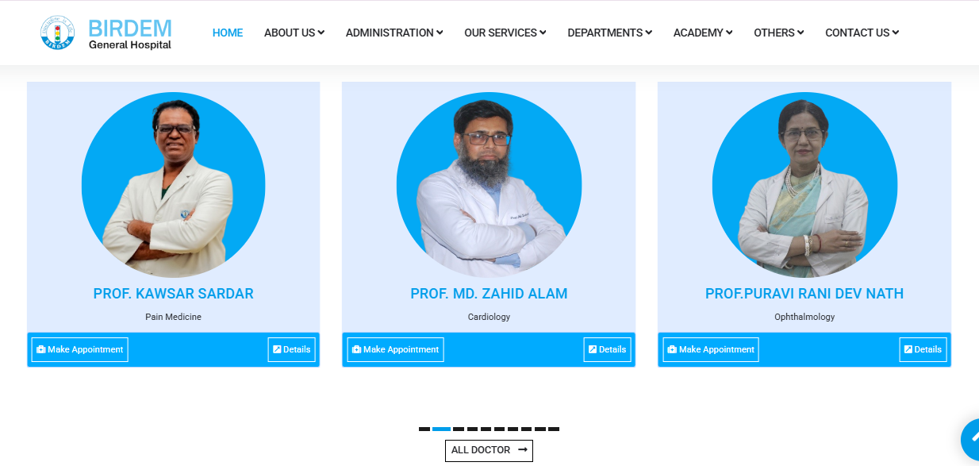

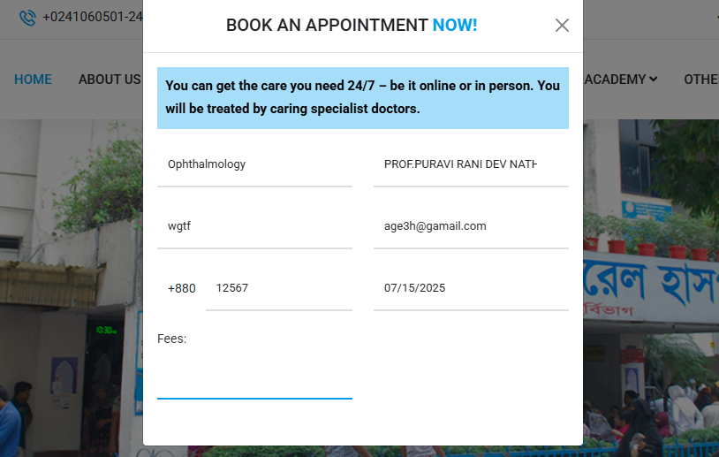

Fig 2.1: Appointment Page of BIRDEM General Hospital.

[2] SQUARE Hospitals Ltd, was established with the goal of providing people with goods and services that improve their quality of life. With a culture of innovation, SQUARE is establishing global corporations with substantial investments across the globe. The association has grown to include enterprises in a variety of industries, including media, consumer goods, healthcare, textiles, and information t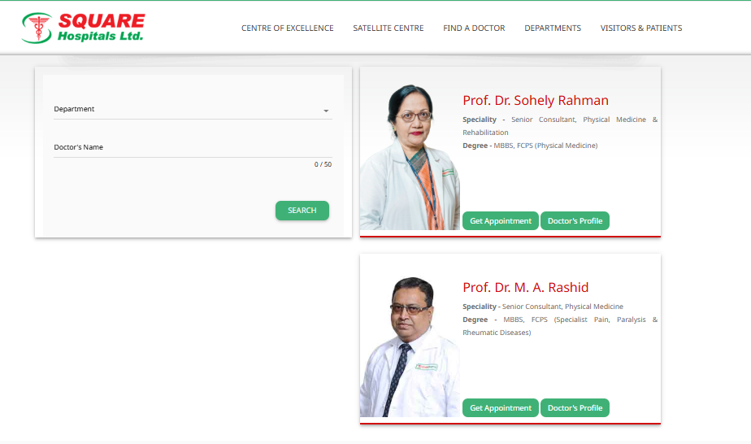

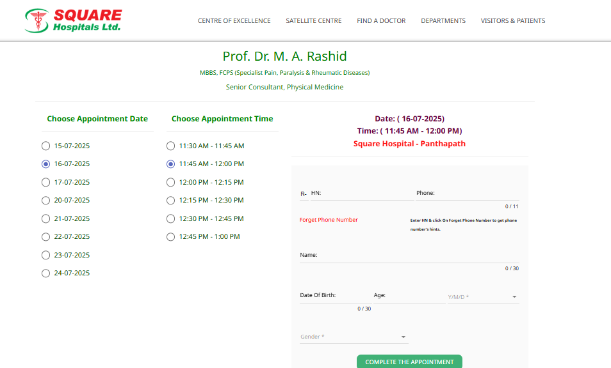

Fig 2.2: Appointment booking of Square Hospital website

[3] The first hospital in Bangladesh to receive JCI accreditation is Evercare Hospital Dhaka, a 425-bed multidisciplinary super specialized tertiary care facility. A U.S.-based accrediting organization, The Joint Commission International (JCI) is committed to enhancing healthcare safety and quality globally. This hospital employs top-notch doctors, skilled nurses, and technicians in the majority of medical specialties, and it has the newest diagnostic tools and technologies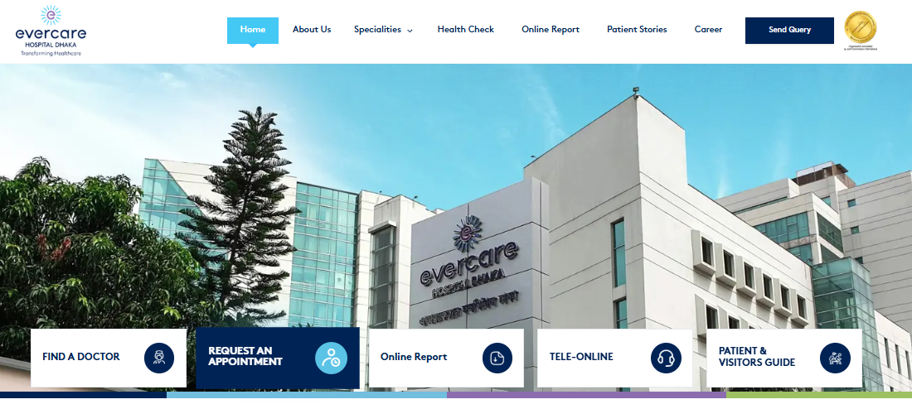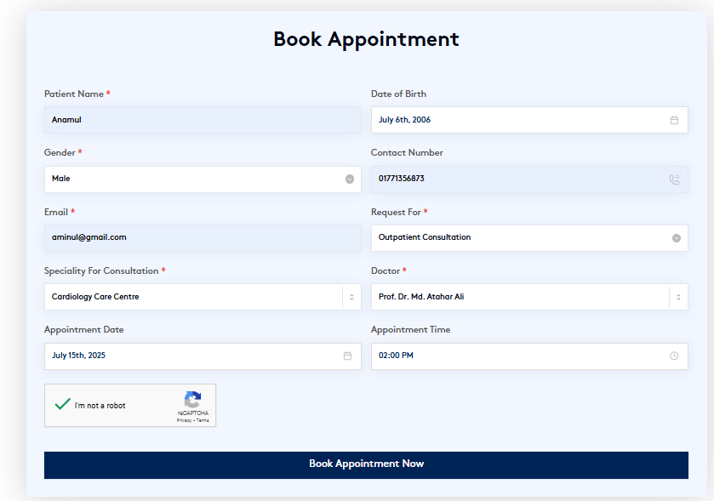

Fig 2.3: Make an Appointment Evercare Hospital Dhaka

[4] The oldest tertiary-level hospital in Bangladesh is Dhaka Medical College Hospital (DMCH), which is situated in the center of Dhaka. This hospital began as a 200-bed field hospital for the British Indian military on July 10, 1946. British major WJ Virgin MIS served as the hospital's first overseer, followed by colonel E.G. Montgomery. Constructed in 1904, the main edifice served as the secretariat office for Asham and the Prince of Brinish Colonies. It has a rich history of democratic struggles, such as the Language Movement in 1952 and the Student Form Liberation War in 1971. It is an academic hospital where graduate and post-graduate students from several disciplines at Dhaka Medical College and Dhaka Nursing College have received their practical training.

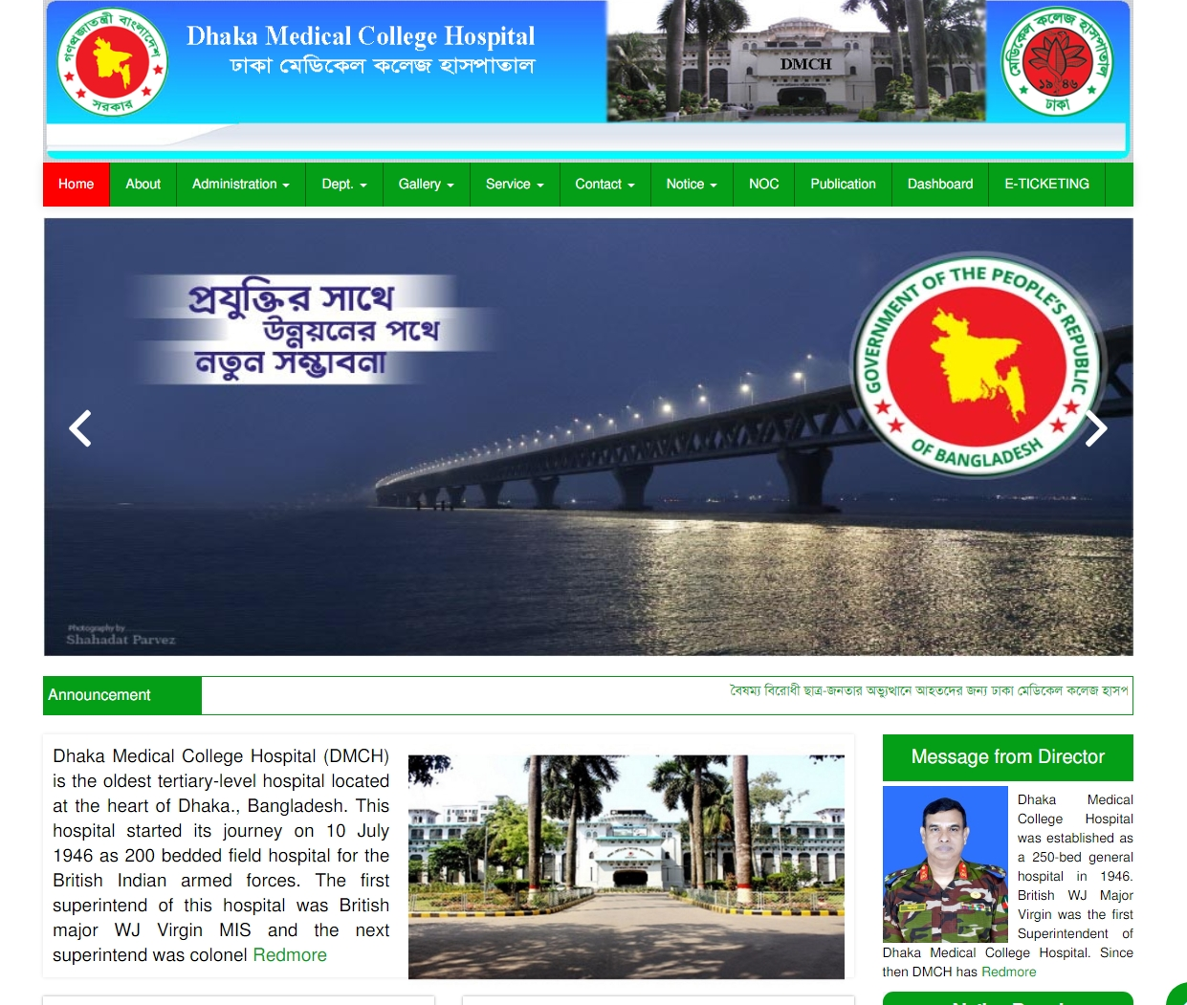

Fig 2.4: Dhaka Medical College Hospital

[5]. As a world-class hospital, BSH provides a wide range of services and specialists, excellent technology and equipment, a friendly atmosphere, and high-quality services. The hospital's use of paperless medical records is a demonstration of how medical technology and ICT Division developments are combining. With the help of state-of-the-art technology and skilled nurses, technologists, and administrators, the medical professionals at Bangladesh Specialized Hospital are able to deliver healthcare that satisfies international standards.

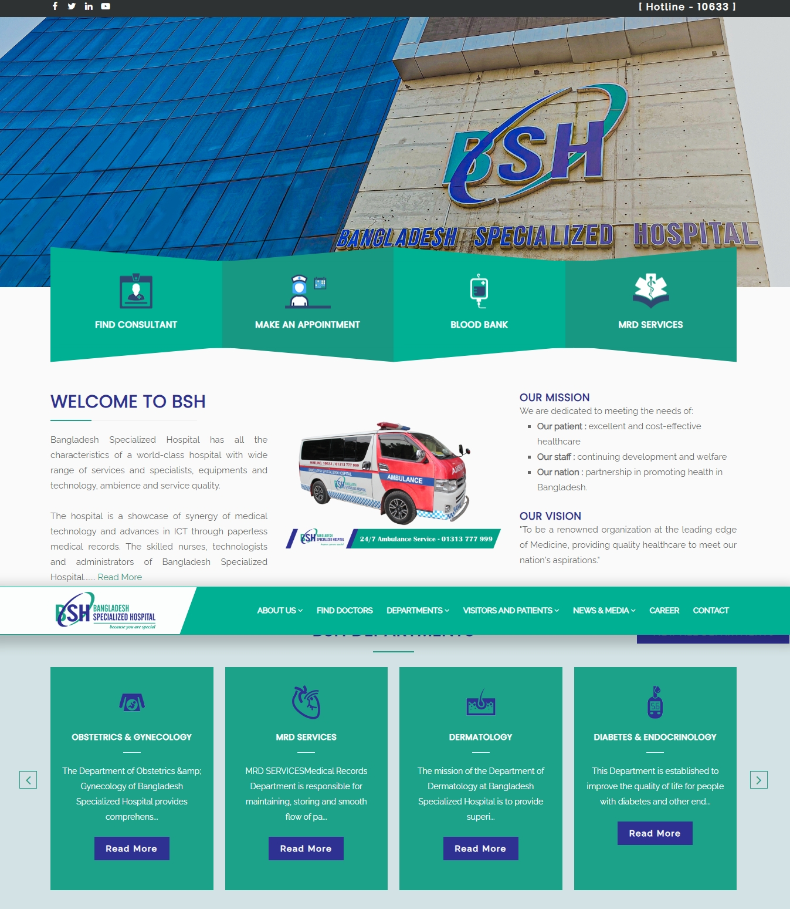

Fig 2.5: Bangladesh Specialized Hospital

[6] In Chittagong, Bangladesh, there is a private hospital called Imperial Hospital Limited, also known as Apollo Imperial Hospitals. Devi Shetty, an Indian cardiac surgeon and businessman, hosted an inauguration event in April 2019 to officially inaugurate IHL.

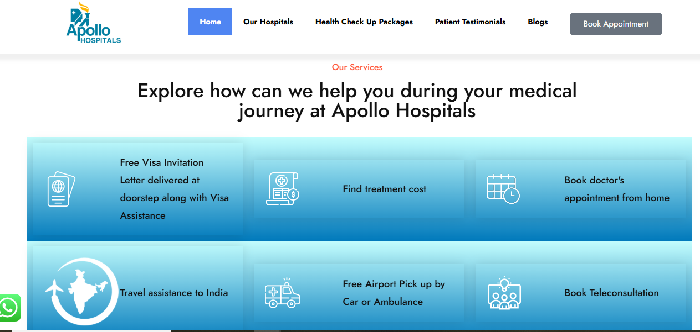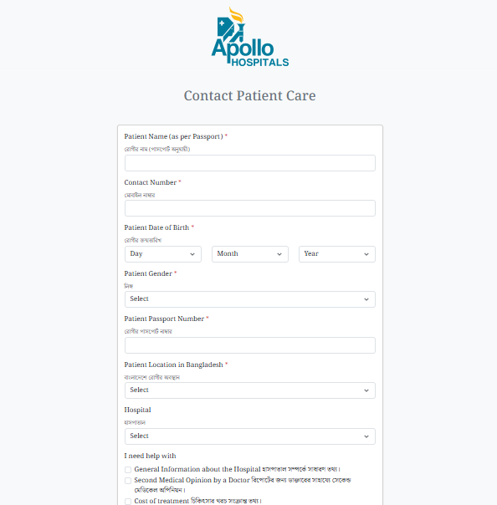

Fig 2.6: Appointment Page of Apollo Imperial Hospitals

[7] One of the top private healthcare providers in Bangladesh is Prime Hospital Ltd. Noakhali is where you can find it. Founded in 1996, Prime Hospital Ltd. has been the first modern technology domestic healthcare facility in Bangladesh, operating for more than 27 years. In the wider Noakhali district, it is currently the top multidisciplinary private hospital. World-class integrated healthcare facilities run by highly skilled experts enable Prime Hospital Ltd. to provide comprehensive care and high-quality clinical outcomes, which contribute to its reputation. manned by a sizable group of committed professionals and a wide range of exceptionally talented experts. Prime Hospital Ltd. works to satisfy patients' needs by providing high-quality medical care and improving their quality of life. Up to 1000 patients can be served every day by the hospital's outpatient department (outdoor), which employs more than 90 consultants. Every day during convenient morning, afternoon, and late evening hours, the outpatient service is available. Other than that, our emergency room is open around-the-clock, every day of the year. In addition, a highly qualified team provides exceptional indoor healthcare services with 150 beds. 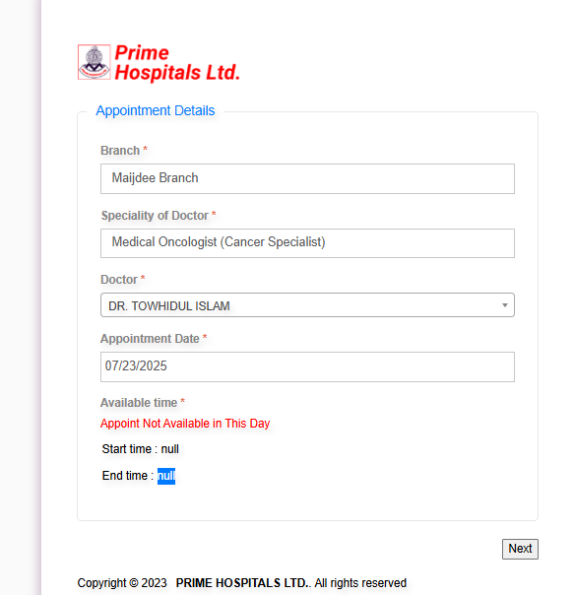

Fig 2.7: Appointment Page of Prime Hospital Ltd.

[9] In the United States, the Mayo Clinic is a private academic medical facility that prioritizes integrated healthcare, education, and research. Its three main campuses are located in Rochester, Minnesota; Jacksonville, Florida; and Phoenix/Scottsdale, Arizona. 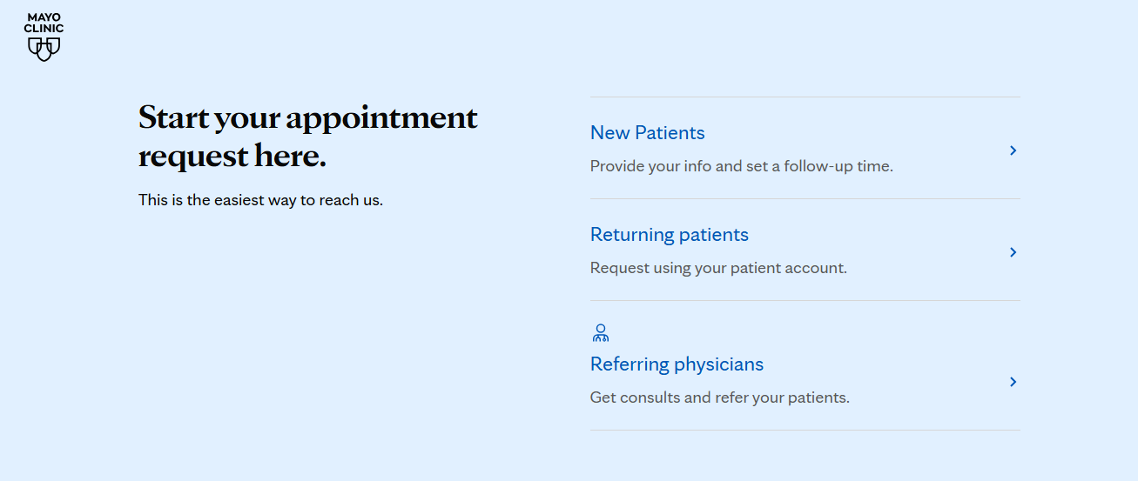

Fig 2.9: Mayo Clinic in Rochester, Minnesota

Table 2.1: A summary of related project on Appointment Booking in HMS.

|  |  |  |  |
| --- | --- | --- | --- |
| Hospital Name | Booking System Type | Doctor Availability Tracking | Notable Features |
| BIRDEM General Hospital | Manual + Semi-Digital | Not real-time | High patient volume; needs improved automation |
| Square Hospital | Digital (In-house platform) | Yes | |  | | --- | |  |   Offers patient portal and SMS notifications   |  | | --- | |  | |
| Evercare Hospital Dhaka | Full Digital (Web & Mobile) | Real-time | JCI-accredited; integrated patient system |
| Dhaka Medical College Hospital | Mostly Manual | No | High load; lacks automation in appointments |
| Bangladesh Specialized Hospital | Web-Based System | Yes | |  | | --- | |  |   Offers doctor search by specialty and time   |  | | --- | |  | |
| Apollo Imperial Hospitals | Digital | Limited | |  | | --- | |  |   Uses Apollo's centralized hospital system   |  | | --- | |  | |
| Prime Hospital Ltd. | Basic Web Booking | Real-time | Affordable services; needs modernization |
| Mayo Clinic | Advanced Digital + App | Real-time | |  | | --- | |  |   Industry leader in tech-enabled healthcare delivery   |  | | --- | |  | |

**Chapter 3**

**METHODOLOGY**

**3.1 Requirement Engineering**

The requirement engineering process for this project focused on understanding the core needs of three primary user groups: **patients, doctors**, and **administrators**. Since the goal was to develop an efficient appointment and emergency management system, the requirements were centered around user experience, scheduling logic, emergency case handling, and secure role-based access.

This phase involved analyzing similar systems, identifying gaps, and gathering requirements specific to real-time appointment workflows. The requirements collected were categorized into **functional** and **non-functional** types.

#### **Key activities included:**

* **Stakeholder Analysis:**  
  Identified main users of the system:
  + Patients *–* to book and manage appointments and emergencies
  + Doctors *–* to manage schedules, complete or cancel appointments
  + Admins *–* to monitor activity, manage doctors and users
* **Requirement Elicitation:**  
  Gathered data through informal interviews with students, healthcare interns, and online research. Studied existing appointment systems to identify strengths and limitations.
* **Requirement Documentation:**  
  Documented key system functionalities including:
  + Patient registration and login
  + Real-time doctor availability display
  + Emergency appointment scheduling
  + Doctor and admin dashboards
  + Role-based access control
* **Requirement Validation:**  
  Cross-checked requirements with project goals to ensure all features aligned with the intended functionality, security standards, and usability expectations. Regular testing and feedback helped refine requirements throughout development.

**3.2 Proposed Process Model**

The HMS will follow an iterative development process, ensuring continuous feedback and incremental improvements. The chosen model will allow flexibility and adaptability to changes during development. The process will consist of the following stages:

The Hospital Management System, An organized method for outlining the steps, tasks, and interactions involved in developing a software application is called a process model. To develop of this system we need to follow an iterative development process model.

**Agile Model:**

[17] The Agile Model was designed to help projects quickly adapt to requests for change. So, the main objective of the Agile methodology is to expedite project completion. To perform this task, agility is required. Agility is obtained by removing processes that may not be required for a particular project and tailoring the process to the project. Wasteful actions of time and effort are also avoided. The Agile Model is a system of development processes. These procedures have a number of essential characteristics, despite some little differences.

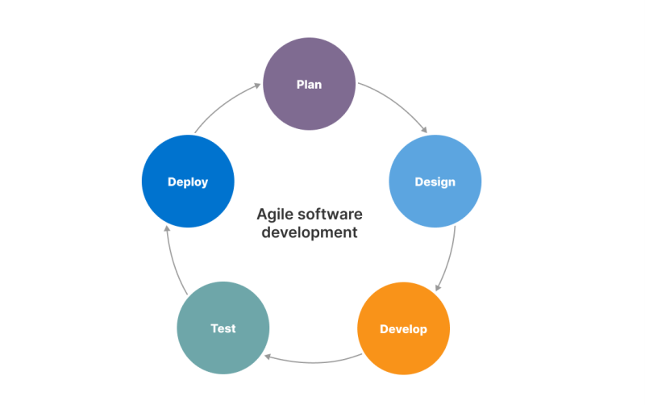

Figure 3.1: Agile Software Development Model.

**3.3 Technologies and Tools**

To create this project using MongoDB, Express.js, React.js, Node.js is a feasible and effective choice that offering scalability, flexibility, and a modern development experience. Using the MERN stack, we will need a combination of frontend development, backend development, database management, security, deployment and monitoring.

**Core Tools and Technologies:**

Technologies for client-side scripting:

* Hypertext Markup Language, or HTML, CSS(Cascading Style Sheets)
* The CSS Framework's Bootstrap
* JavaScript
* JavaScript Framework Library, or React Js

Technologies for server-side scripting:

* Express.js(for building RESTful APIs)
* Node.js(server-side JavaScript runtime)

Database Related Tools:

* NoSQL database MongoDB
* MongoDB ODM (Mongoose)

System for hosting and version control:

* Heroku(for free hosting for small scale testing)
* Vercel (with serverless Functions MERN stack for limited backend logic)
* GIT(for version control system)

(i)**HTML:**

The internet's most basic building block is HTML, or HyperText Markup Language. Web content determines its structure and meaning. Most of the time, technologies other than HTML are used to describe the design and presentation (CSS) or functionality and behavior (JavaScript) of a web page. In [9]

**(ii) CSS:**

**To define the presentation of an HTML or XML document (including XML dialects like SVG, MathML, or XHTML), a stylesheet language known as Cascading Style Sheets (CSS) is utilized. CSS defines the appearance of elements in text, speech, screens, and other media.[10]**

(iii) **Tailwind CSS:**

Tailwind CSS is a modern, utility-first class framework that allows developers to style their websites directly within HTML using concise utility classes. Unlike traditional CSS, Tailwind CSS promotes rapid development by eliminating the need to write custom styles for every component. With over 40% of developers adopting it in new projects, Tailwind CSS is quickly becoming a go-to choice for building responsive, scalable, and maintainable UIs..[11]

# **(iv) JavaScript:**

First-class functions are included in JavaScript (JS), a straightforward interpreted (or just-in-time constructed) programming language. Web page scripting is its most well-known use, although it is also utilized in various non-browser contexts, such as Apache CouchDB, Node.js, and Adobe Acrobat. JavaScript supports imperative, object-oriented, and declarative programming techniques, including functional programming. It is a single-threaded, dynamic language with multiple paradigms that is prototype-based.[12]

## **(v) React:**

**Web user interfaces (UIs) are created using the React library in JavaScript.. Programmers may develop reusable user interface elements with React, a declarative, component-based framework. To increase rendering speed, it makes advantage of the Virtual DOM (Document Object Model) method, which reduces DOM updates. React is fast and easily combines with other technologies and libraries.[13]**

(vi) **Node.js:**

Node.js is an open-source, cross-platform environment for running JavaScript. It is a popular tool for almost every kind of assignment! Google Chrome's V8 JavaScript engine is powered by Node.js outside of the browser. This makes Node.js's fast performance possible. Instead of starting a new thread for each request, a Node.js application operates in a single process.. In Node.js libraries, blocking behavior is the exception rather than the rule because non-blocking paradigms are usually used in their design. Additionally, a set of asynchronous I/O primitives that stop JavaScript code from blocking are included in the standard library of Node.js.[14]

(vii) **Express.js:**

Express JS is a Node.js web development platform. This framework can be used to construct single-page, multi-page, and hybrid web applications. It manages servers, routes, asynchronous, single treads, and more. It also offers faster input/output. It facilitates end-to-end, integration, and unit testing. With the help of this framework, you can quickly scale your application and use JS for both front-end and back-end development. The Google v8 engine supports it, which improves its performance [14].

(viii) **MongoDB:**

An open source NoSQL database management solution is called MongoDB.. It is possible for NoSQL (not just SQL) to replace conventional relational databases. NoSQL databases greatly simplify the process of working with large, scattered data sets. MongoDB can be used to organize, store, and retrieve document-oriented data. Businesses can swiftly store vast volumes of data because to MongoDB's high-volume data storage capabilities. Ad hoc queries, indexing, load balancing, aggregation, server-side JavaScript execution, and other functionalities are some of the additional reasons why companies adopt MongoDB [15].

(ix) **Mongoose:**

Mongoose is an object data modeling (ODM) module for Node.js and MongoDB. It manages data relationships, provides schema validation, and converts between coded things and their MongoDB representations [16].

**Software Requirements:**

* Operating System: Linux, Windows XP or Later
* Browser: Google Chrome, Firefox
* Editor: Notepad++, Visual Studio Code, Sublime Text or any text editor.

**Hardware Requirements:**

* + Processor: Standard Processor
  + RAM: 2 GB RAM or more
  + Hard Disk: 50 GB or more
  + Monitor: Standard Monitor
  + Keyboard: Standard Keyboard
  + Mouse: Standard Mouse

**Requirement for Windows:**

* 64-bit Microsoft® Windows® 8/10
* X86_64 CPU architecture; 2nd generation Intel Core or newer, or AMD CPU with support for a windows Hypervisor
* 8 GB Ram or more
* 8 GB of available disk space minimum (IDE + Android SDK + Android Emulator)
* 1280 x 800 minimum screen resolution

**3.4 Use Case Diagram**

A Use Case Diagram are used to represent the visual representation of how users, doctors and admin are interact the system with respect to system requirement. Here the key entities are actors which are represent as patients, doctors and admin and they connected with system functionalities using connecting lines.

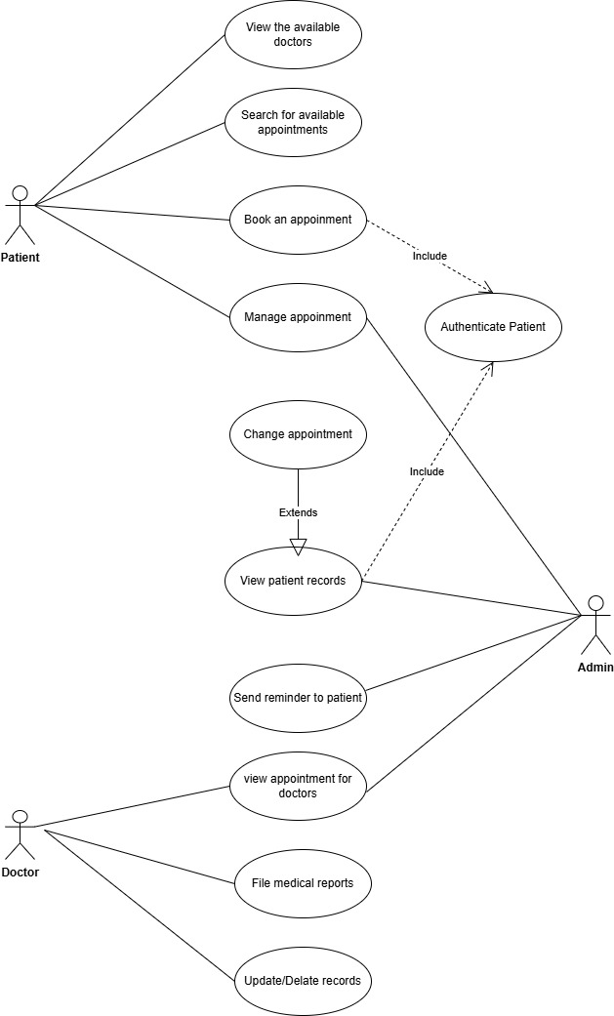

Fig 3.2: Use Case Diagram of appointment booking system

**3.5 E-R Diagram**

The ER (Entity-Relationship) diagram of **Prescripto** shows how the main parts of the system **Patient, Doctor, Admin,** and **Appointment** are connected.

**Main Entities:**

* **Patient:**  
  A user who can register, log in, and book appointments.
* **Doctor:**  
  A user who manages their schedule, views appointments, and marks them as completed or canceled.
* **Admin:**  
  A user who controls the system — adds doctors, manages users, and oversees appointments.
* **Appointment:**  
  Connects patients and doctors. It includes date, time, fees, emergency status, and appointment status.

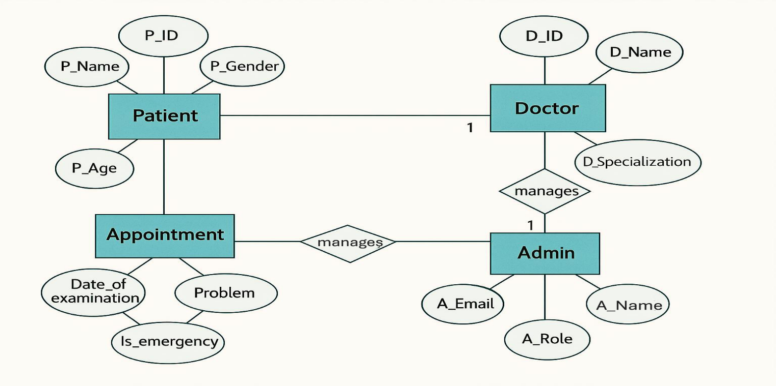

Fig 3.3: ER diagram of appointment management System

**3.6 Testing**

Testing strategies include:

* Unit Testing**:** Verifying the functionality of individual components.
* Integration Testing**:** Ensuring seamless communication between different system modules.
* System Testing**:** Evaluating the complete system for compliance with requirements.
* User Acceptance Testing (UAT): Gaining approval from end-users by validating real-world functionality.
* Security Testing: Assessing vulnerabilities and ensuring data protection measures.

**3.7 Maintenance**

Ongoing system maintenance will address updates, performance enhancements, and security patches. The maintenance strategy includes:

* Corrective Maintenance**:** Fixing identified bugs and performance issues.
* Adaptive Maintenance**:** Updating the system to comply with new regulations and hospital policies.
* Preventive Maintenance**:** Regular system audits to avoid future issues.
* Enhancements**:** Adding new features based on user feedback and technological advancements.

**Chapter 4**

**RESULT**

**4.1 Home Page**

The home page is the landing screen for all users. It provides basic navigation to different sections like About, Contact, Doctors, Login, and Register. It is designed with a clean, responsive layout and highlights the key services offered by Prescripto.

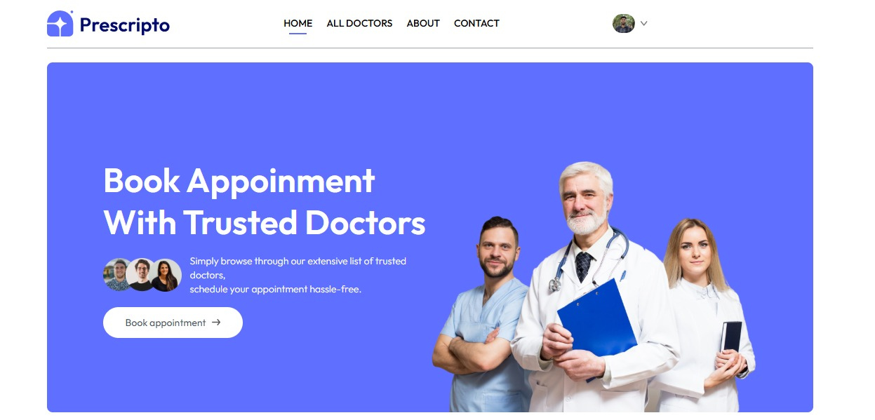

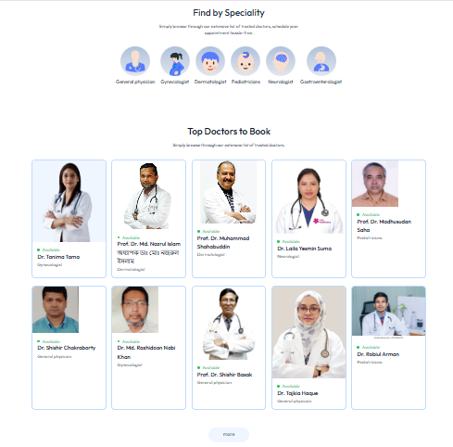

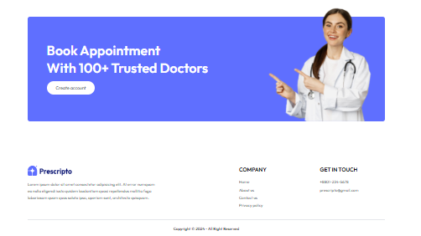

Figure 4.1 Home Page

### **4.2 About Us Page**

This section gives users a brief introduction to the project’s purpose — digitalizing the hospital appointment system. It explains the system's goals in improving scheduling efficiency, handling emergencies, and enhancing patient experience.

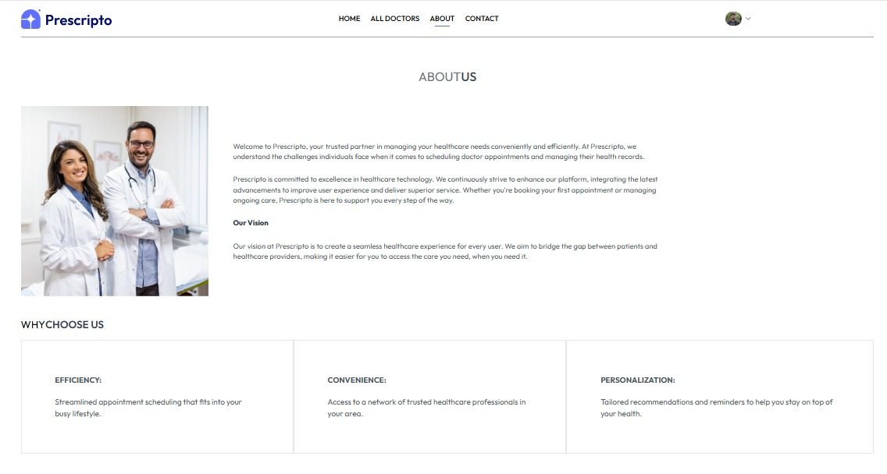

Figure 4.2 About Us Page

### **4.3 Contact Us Page**

Contains a simple contact form and hospital contact details. Patients or users can reach out for support or send general queries. It includes fields like name, email, message, and contact number.

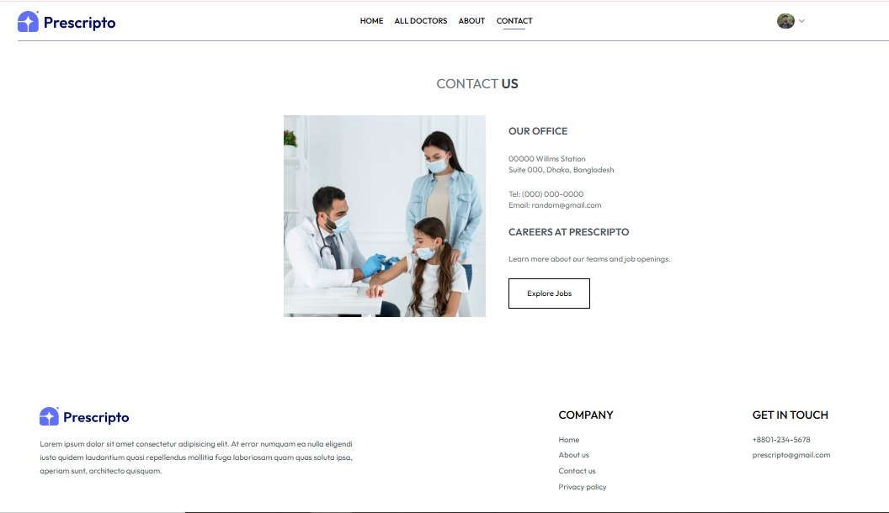

Figure 4.3 Contact Us Page

**4.4 All Doctors Page**

Displays a list of all registered doctors with their name, specialization, availability, and consultation fee. Users can view details and choose a doctor for booking an appointment.

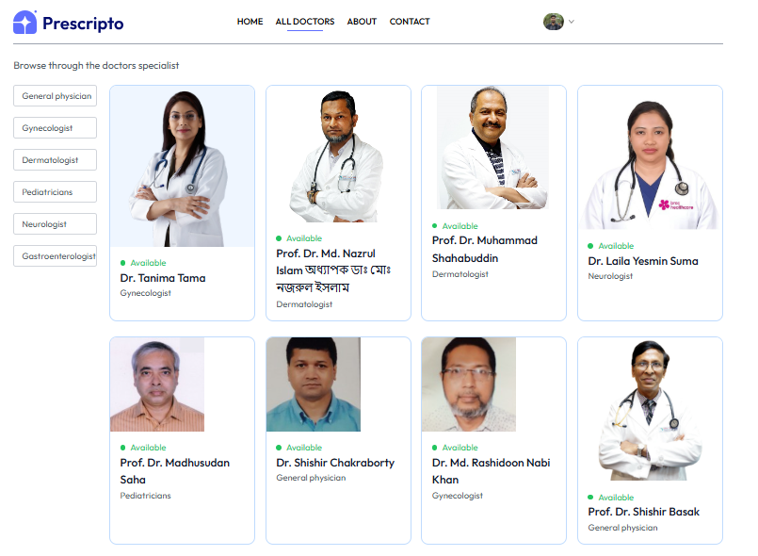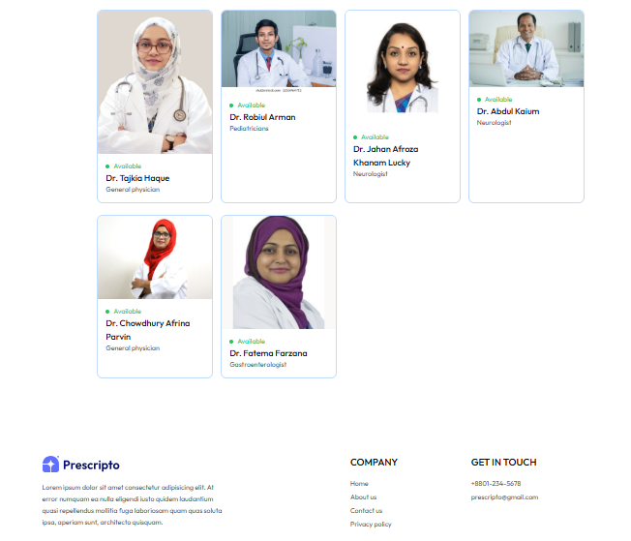

Figure 4.4 All Doctors Page

### **4.5 Search by Specialty**

Users can filter doctors by specialization (e.g., cardiologist, neurologist). This feature makes it easy for patients to find the right doctor based on their health needs.

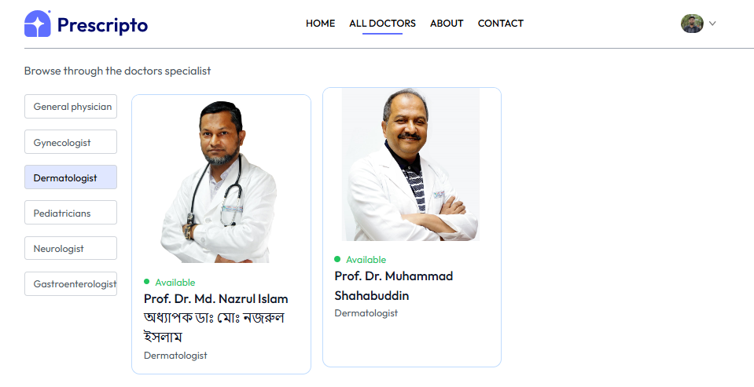 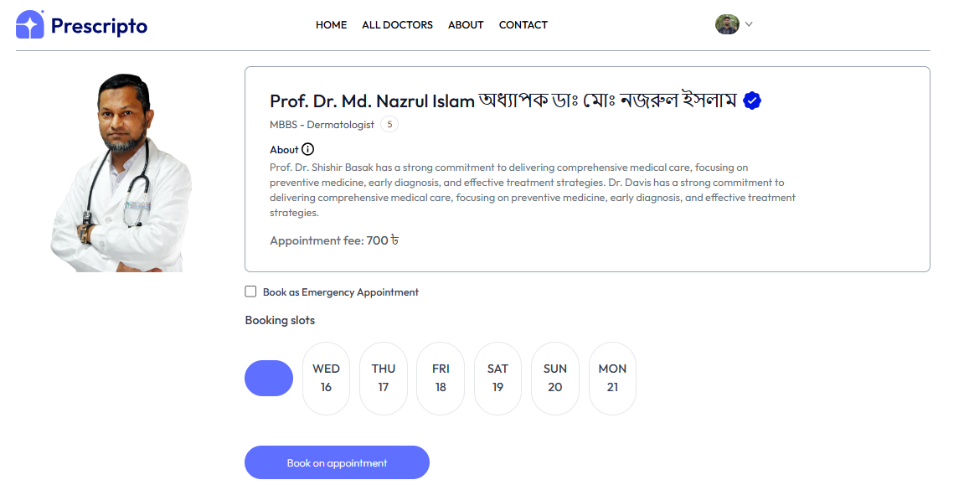 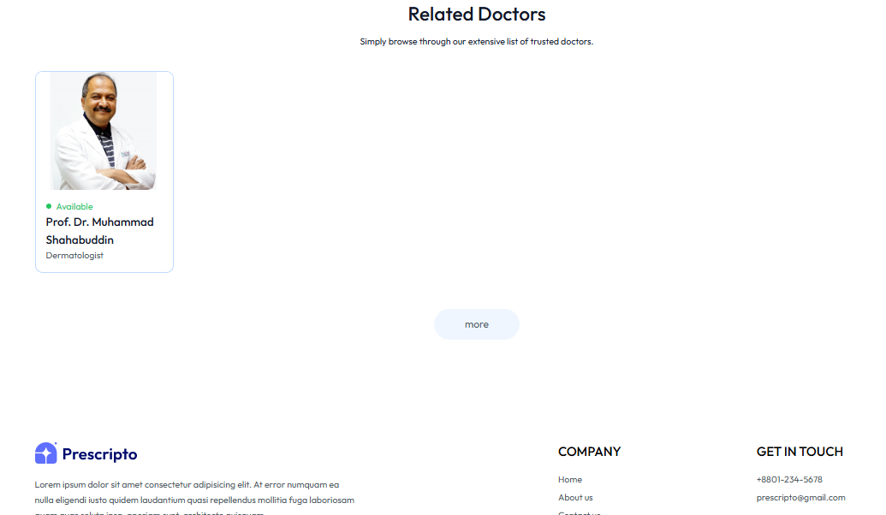

Figure 4.5 Search by Specialty

**4.6 Make an Appointment:**

Patients can select a doctor, choose an available date and time, and confirm a regular appointment. The system checks for time slot availability and prevents double-booking.

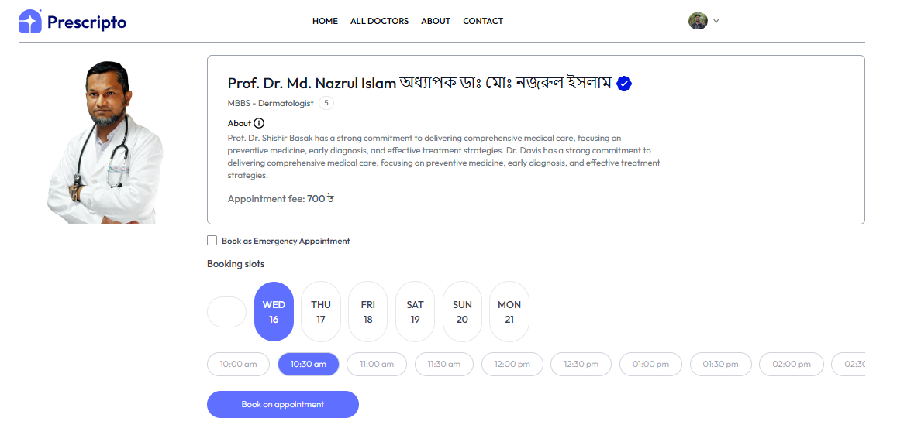

Figure 4.6 Make an Appointment

**4.7 Emergency Appointment:**

This feature allows patients to book urgent appointments by bypassing regular scheduling. The system automatically shifts regular appointments to accommodate emergencies and notifies doctors accordingly.

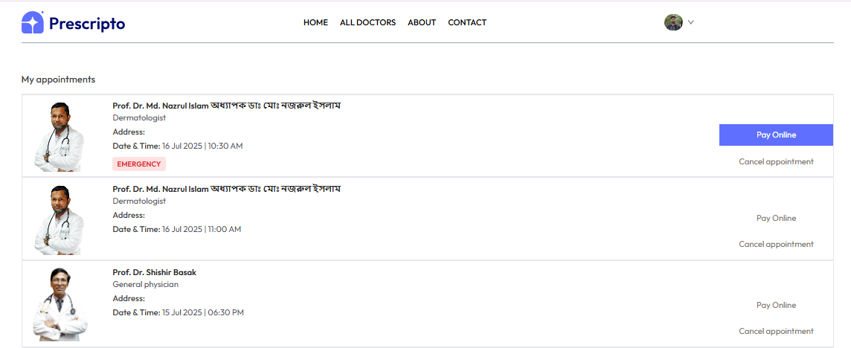

Figure 4.7 Emergency Appointment

**4. 8 Pay Online**

After selecting a time slot, patients can choose to pay online (or in cash). This screen shows appointment fees and available payment methods, integrating a digital gateway for smooth transactions.

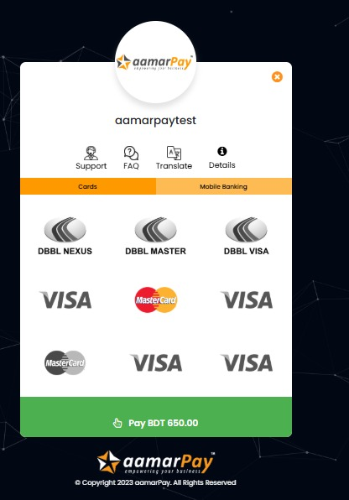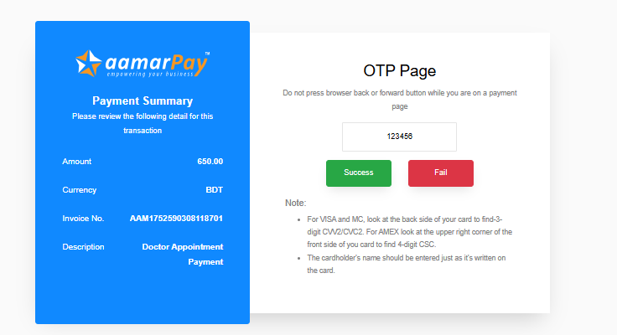 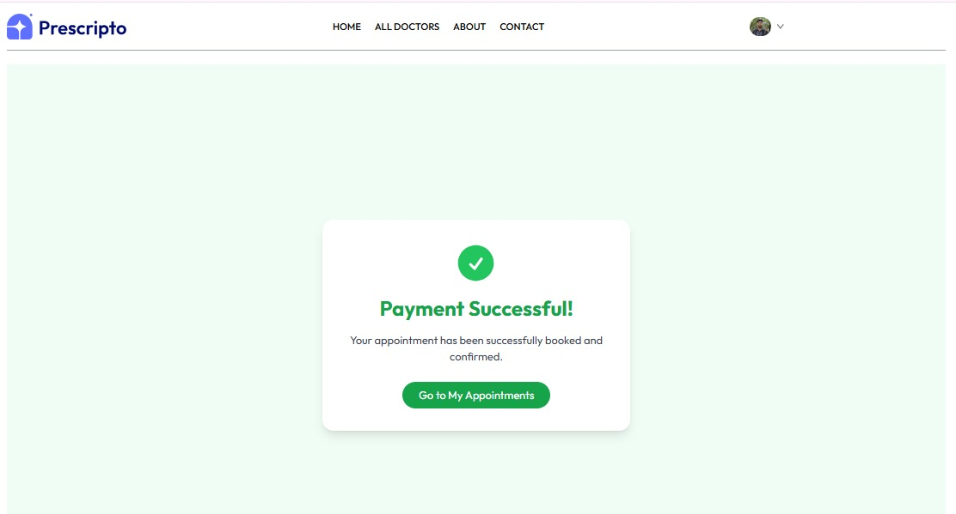 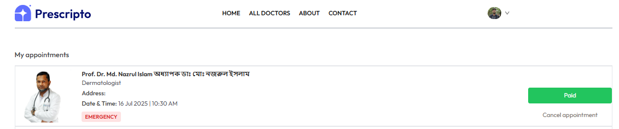

Figure 4.8 Pay Online

**4.9 Cancel an Appointment**

Patients or doctors can cancel appointments. Once canceled, the slot becomes available for others. The status is updated in real time for transparency and proper management.

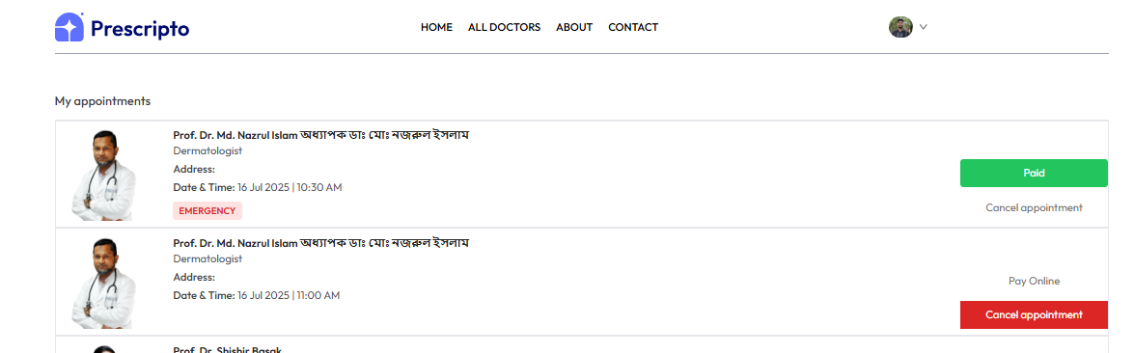

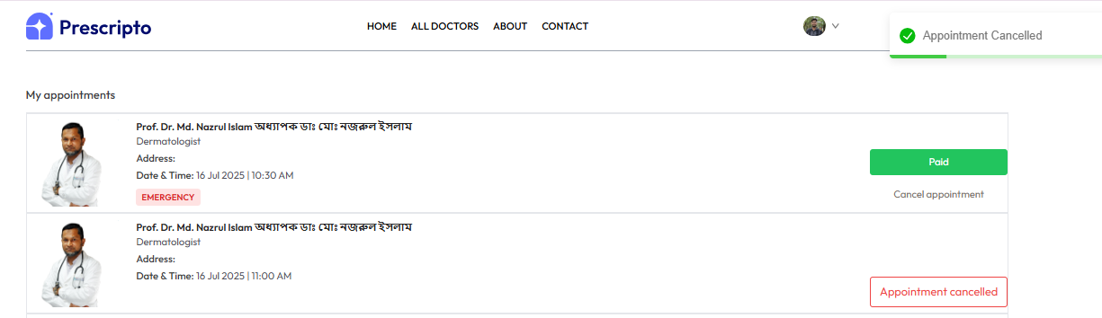

Figure 4.9 Cancel an Appointment

**4.10 User Login, register and Profile**

Patients can create an account, log in securely, and manage their profile. The profile page shows notification message, appointment history, payment status, and allows editing personal info. Patient can successfully logout from their account.

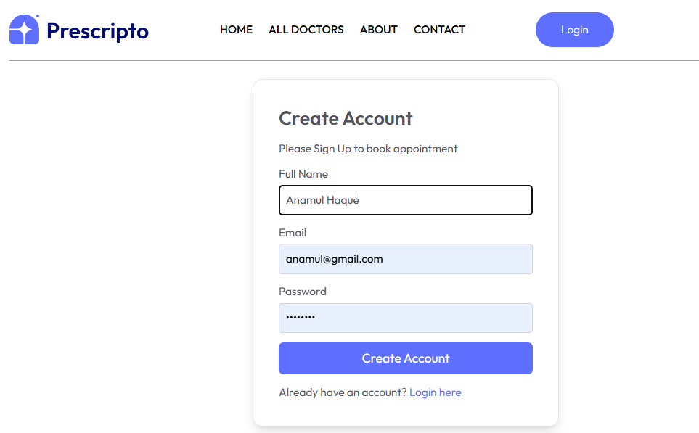 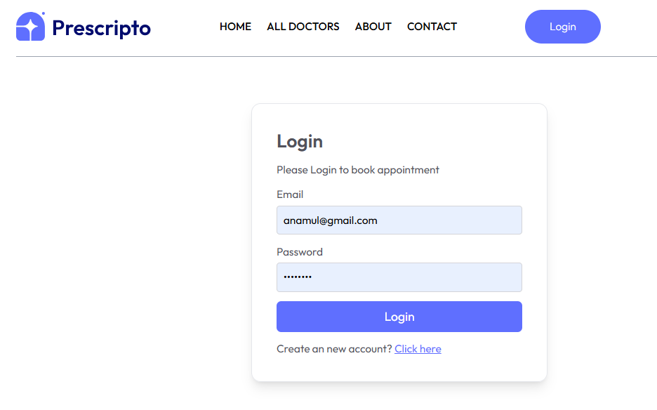

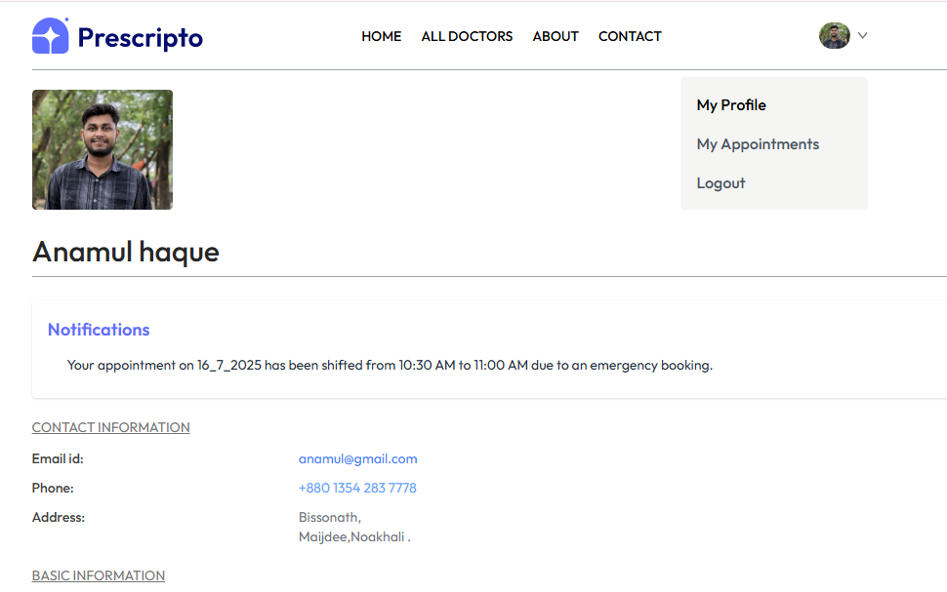 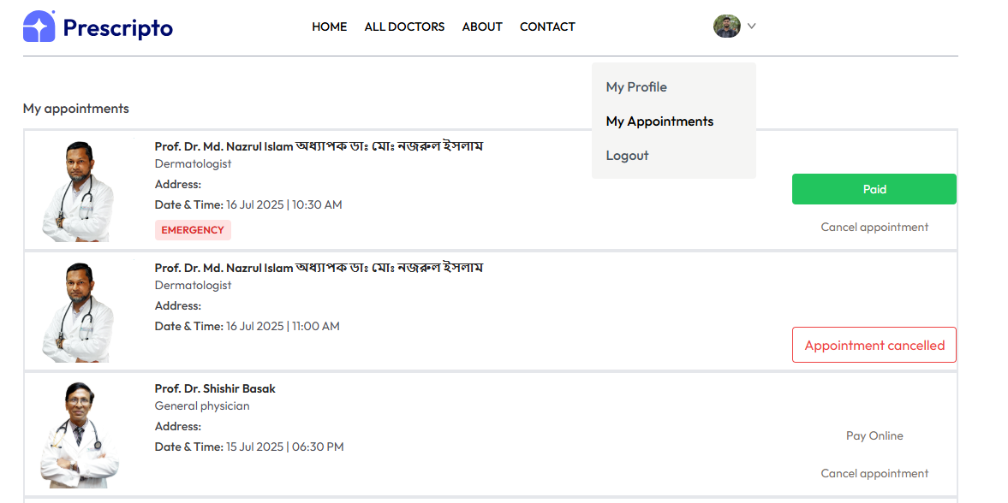

Figure 4.10 User Login, register and Profile

**4. 11 Admin Login and Doctors Login**

Separate login portals are provided for doctors and admins. Each login leads to a role-specific dashboard with different controls and access levels based on user type.

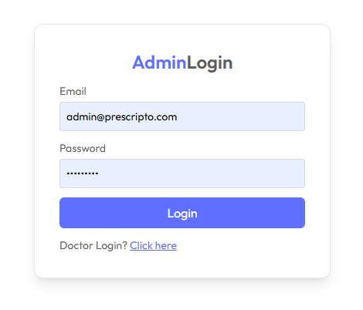 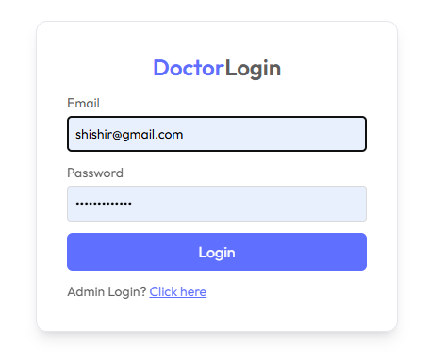

Figure 4.11 Admin Login and Doctors Login

**4. 12 Admin Panel**

The Admin Panel is a centralized dashboard designed for hospital administrators to manage users, doctors, and appointments efficiently. It offers role-based access and provides real-time control over system activities.

Admin users can:

* View total doctors, patients, and appointments
* Add/edit/delete doctors
* Monitor latest bookings
* Manage Doctors availability
* Manage the system from a central dashboard

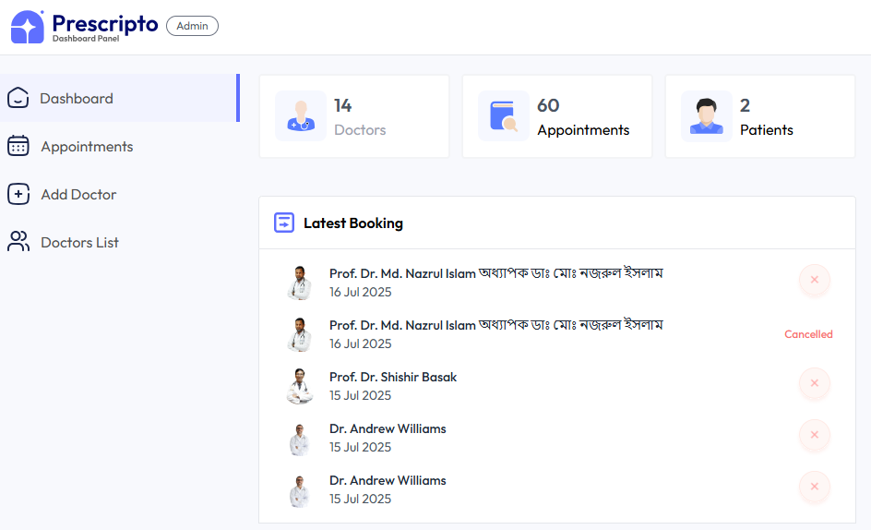  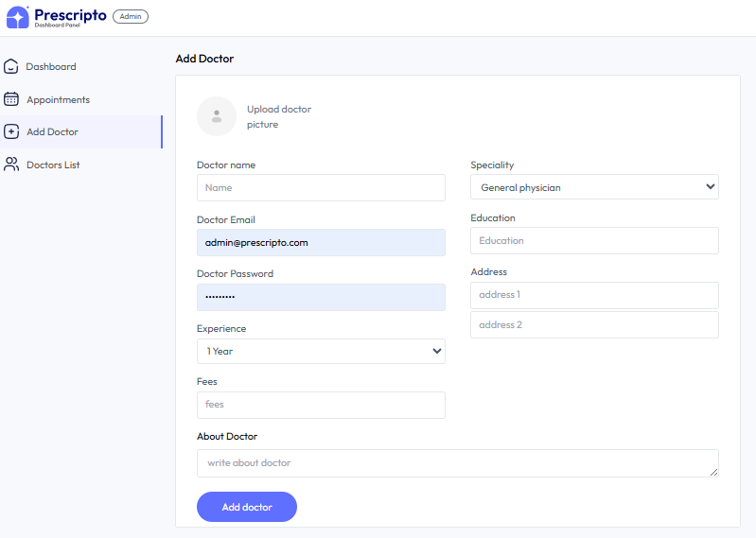  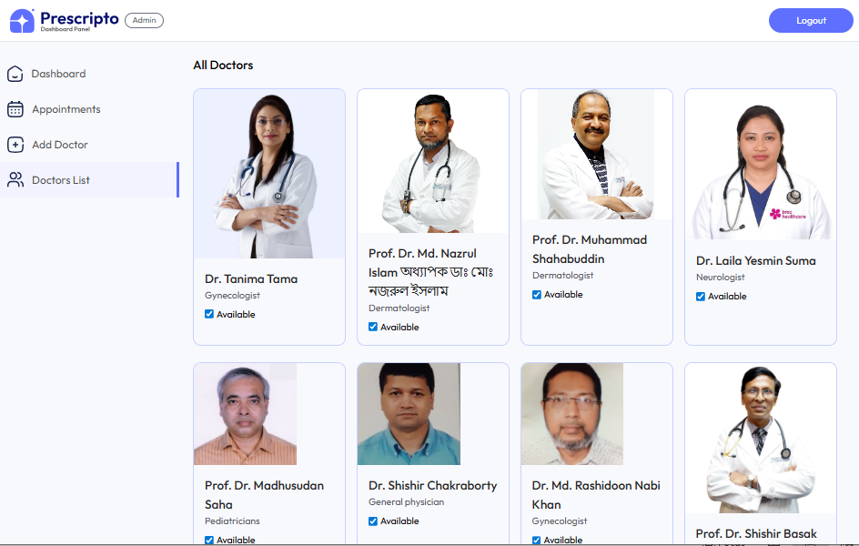

Figure 4.12 Admin Panel

**4. 13 Doctor Panel**

Doctors can:

* View a personalized dashboard showing total earnings, appointments, and patients
* View upcoming and past appointments
* Mark appointments as completed or canceled
* See emergency tags for urgent bookings
* Manage their availability and working schedule
* Update their profile details and consultation fees
* Monitor the latest bookings in real-time
* Logout securely from the system

This panel helps doctors stay organized, handle emergency cases efficiently, and manage their daily appointment flow with ease. 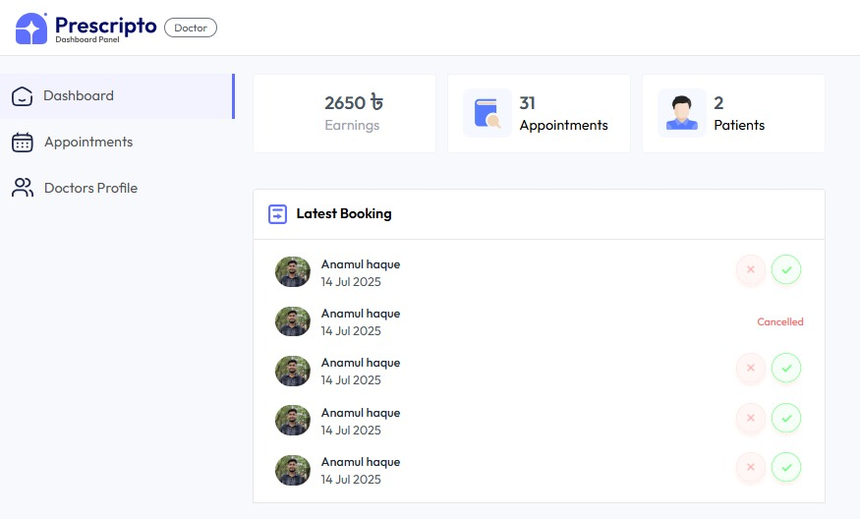 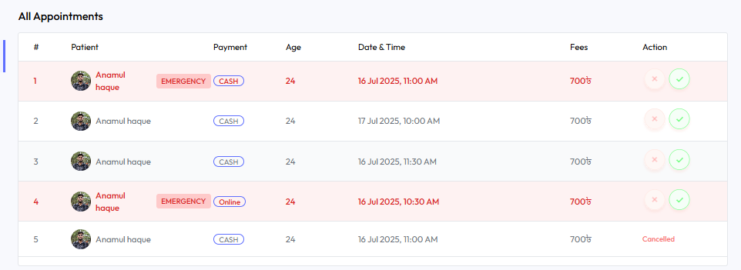  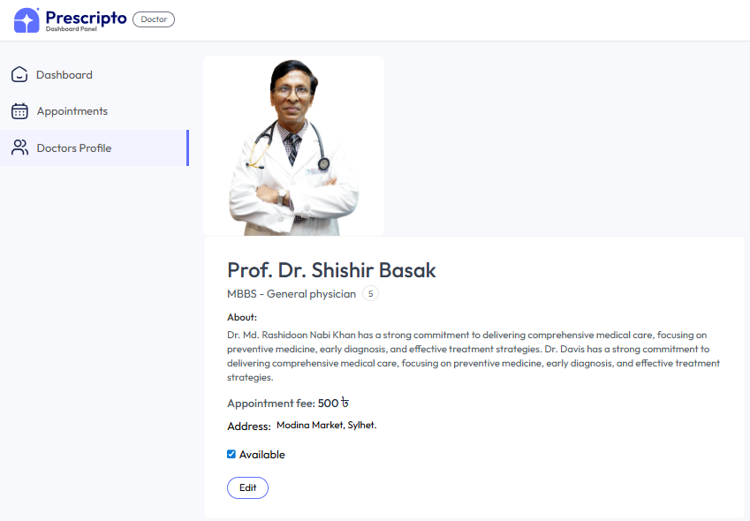

Figure 4.13 Doctor Panel

**Chapter 5**

**CONCLUSION**

**5.1 Conclusion**

The Prescripto project was developed to solve key issues in hospital appointment workflows, such as manual scheduling, emergency handling delays, and lack of proper admin control. By focusing on appointment and emergency management, this system ensures better coordination between patients, doctors, and administrators.

Prescripto simplifies the patient experience by offering:

* Easy registration and login
* Real-time doctor availability
* Emergency appointment handling
* Role-based dashboards for patients, doctors, and admins

The system enhances hospital efficiency by reducing errors, automating appointment flows, and improving response times — especially during emergencies. Admin users have full control over doctors and appointments, ensuring smooth operations.

**5.2 Future Work**

In future versions, Prescripto can be extended with more features to offer a broader hospital experience. Possible enhancements include:

* Mobile App Integration — for patients and doctors to manage appointments from their phones.
* Patient Feedback System — for collecting suggestions and ratings
* Stronger Security & Compliance — including better data encryption and healthcare law support

**REFERENCES:**

[1] BIRDEM, "Birdem General Hospital," https://birdembd.org/, Accessed: Jan. 10, 2025.

[2] Square Group, "About Us," https://squaregroup.com/about-us/, Accessed: Jan. 15, 2025.

[3] Evercare Hospital Dhaka, "About Us," https://www.evercarebd.com/dhaka/about-us/, Accessed: Jan. 15, 2025.

[4] Dhaka Medical College Hospital, "About DMCH," https://dmch.gov.bd/about/dhaka-medical-college-hospital/, Accessed: Jan. 15, 2025.

[5] Bangladesh Specialized Hospital, "About BSHL," https://www.bdspecializedhospital.com/about/about-bshl, Accessed: Dec. 15, 2024.

[6] Anwer Khan Modern Hospital Ltd., "AIHL," https://aihlbd.org/, Accessed: Feb. 10, 2025.

[7] Prime Hospital Ltd., "Homepage," https://www.primehospitalltd.com/, Accessed: Feb. 18, 2025.

[8] AIIMS, "About AIIMS," https://www.aiims.edu/index.php/en/about-us/2019-02-06-05-47-04, Accessed: Mar. 15, 2025.

[9] DevDocs, "HTML Documentation," https://devdocs.io/html/, Accessed: Mar. 20, 2025.

[10] Tailwind CSS, "Official Website," https://tailwindcss.com/, Accessed: Jun. 8, 2025.

[11] Mozilla Developer Network, "CSS Docs," https://developer.mozilla.org/en-US/docs/Web/CSS, Accessed: Jun. 23, 2025.

[12] TechTarget, "Bootstrap Definition," https://www.techtarget.com/whatis/definition/bootstrap, Accessed: Jan. 25, 2025.

[13] Mozilla Developer Network, "JavaScript Docs," https://developer.mozilla.org/en-US/docs/Web/JavaScript, Accessed: Jun. 25, 2025.

[14] Node.js, "Introduction to Node.js," https://nodejs.org/en/learn/getting-started/introduction-to-nodejs, Accessed: Jun. 12, 2025.

[15] BrowserStack, "Web Development Tools," https://www.browserstack.com/guide/web-development-tools, Accessed: Jul. 10, 2025.

[16] TechTarget, "MongoDB Definition," https://www.techtarget.com/searchdatamanagement/definition/MongoDB, Accessed: Jul. 11, 2025.

[17] FreeCodeCamp, "Introduction to Mongoose for MongoDB," https://www.freecodecamp.org/news/introduction-to-mongoose-for-mongodb-d2a7aa593c57/, Accessed: Jan. 20, 2025.

[18] GeeksforGeeks, "Agile Development Models," https://www.geeksforgeeks.org/software-engineering-agile-development-models/, Accessed: Jan. 25, 2025.